**Assignment 13**

**Task 1: Create Tooltips**

Step 1: Add a new page in Authors.pbix.Select a stacked bar chart from the Visualization

Step 2: In the Page formatting section. Set Type -> Tooltip and turn Tooltip->ON under Page information.

Step 3: In the Visual, add column name Title in Axis and Volume in Values.And then add Author in Page tooltip section

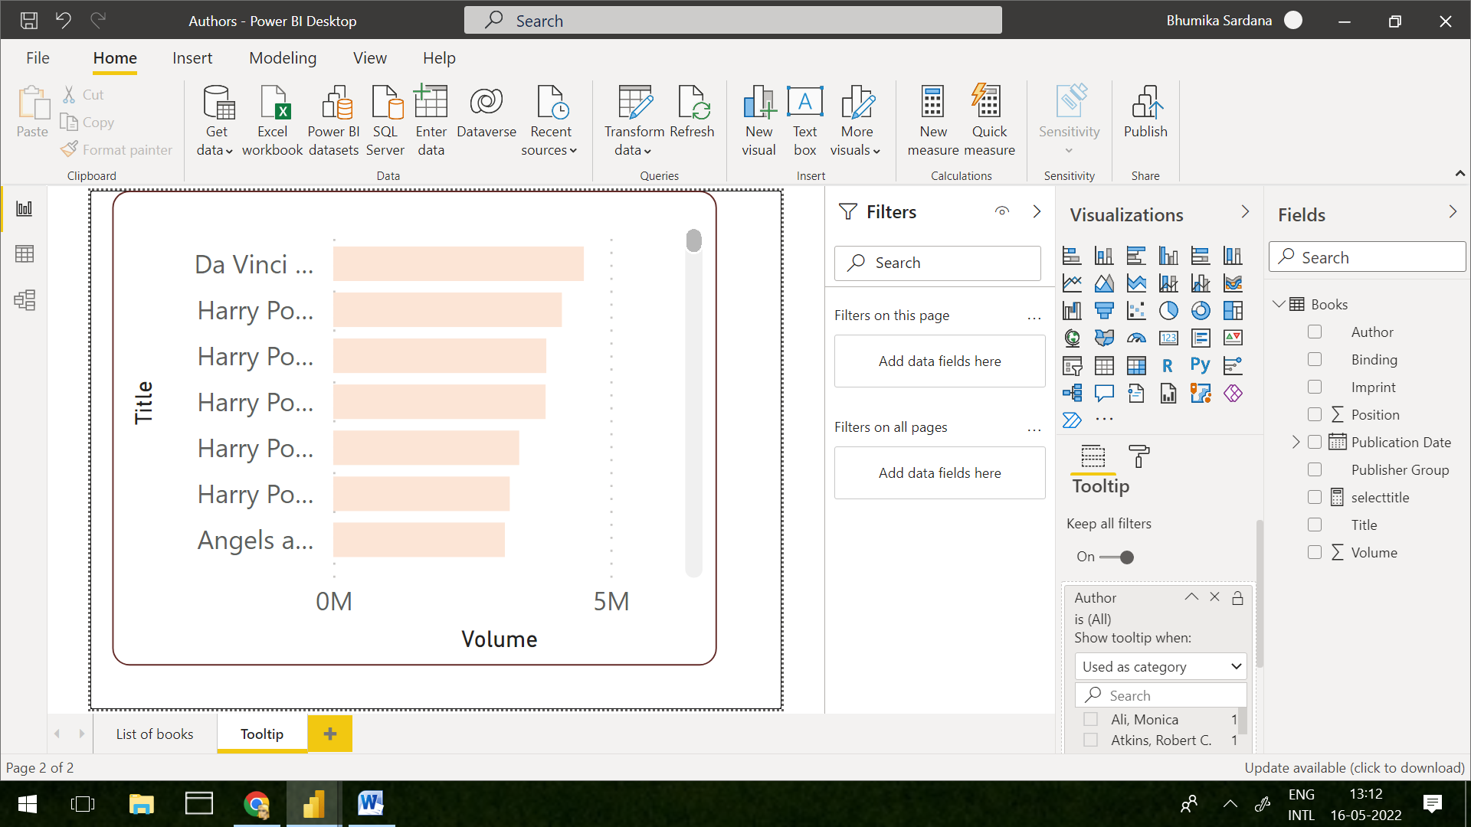

Step 4: Navigate to List of Books and in Format Section Turn ON the tooltip.Assign the Page tooltip(Created)

**Task 2: create and display a measure to show the name of the author in your tooltip**

Step 5: Under Home Section->New measure

Step 6: Create Measure using following formula

selecttitle = SELECTEDVALUE(Books[Author])

Step 7: Add the measure in Title Text under title

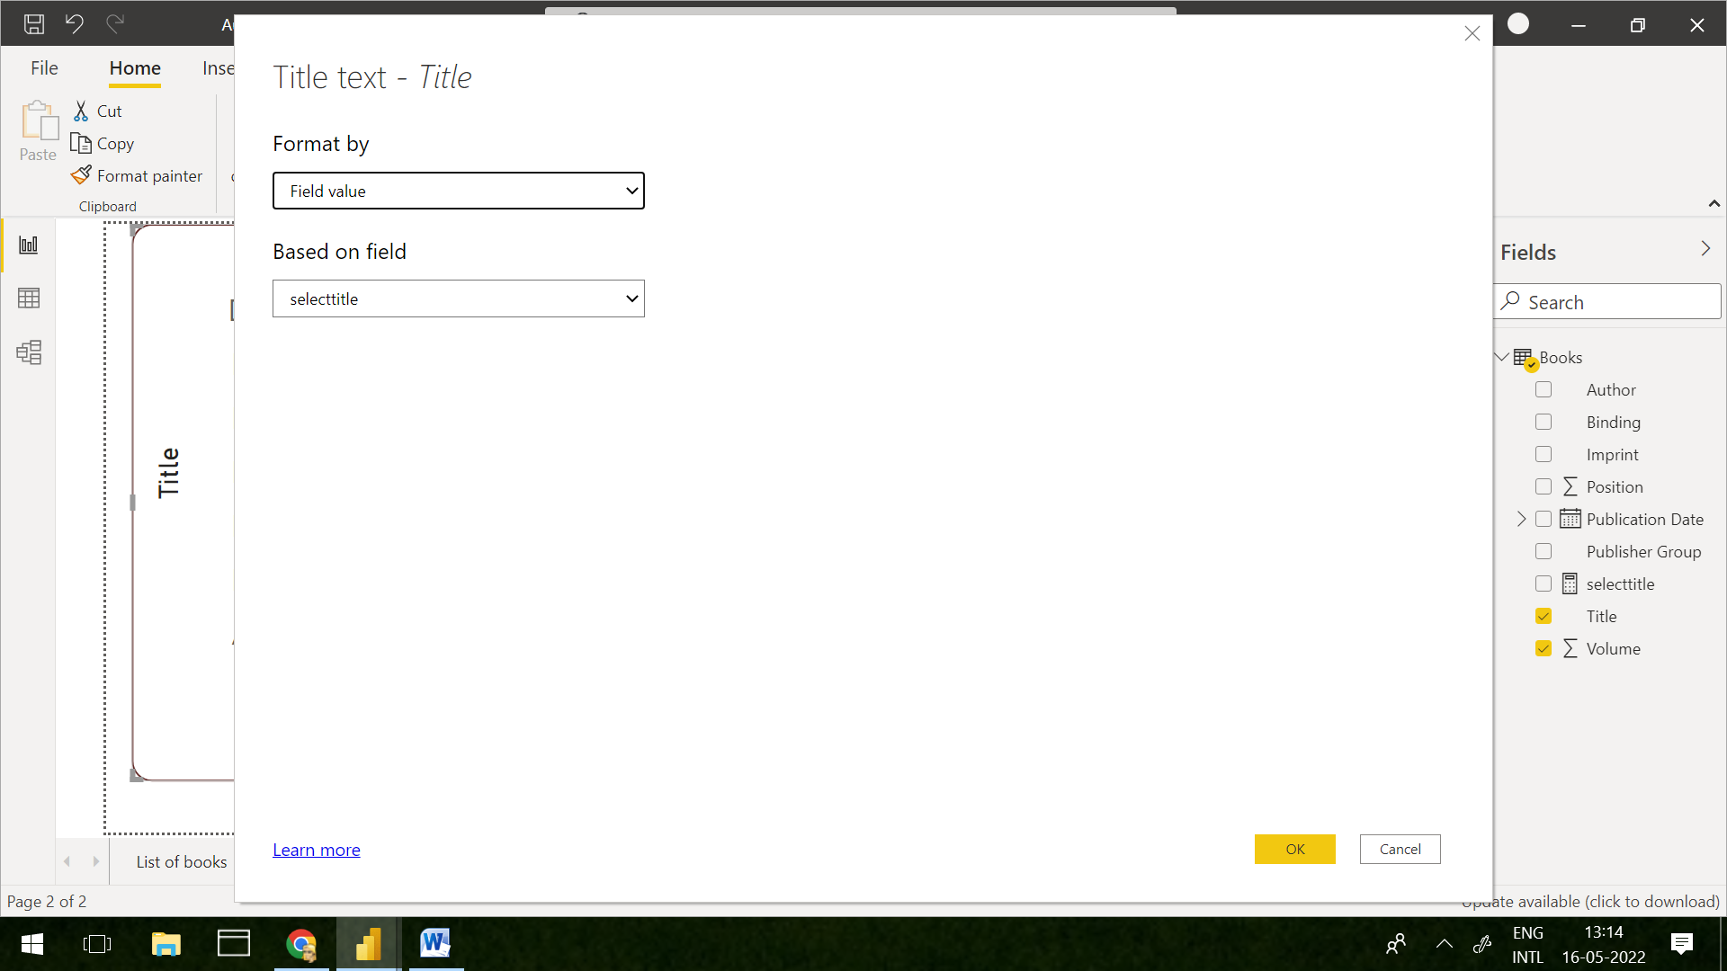

**Expected Output**

